**dubbo zookeeper**

dubbo监控：<https://github.com/apache/dubbo-admin>

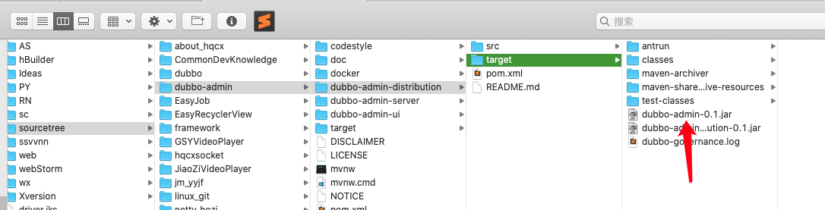

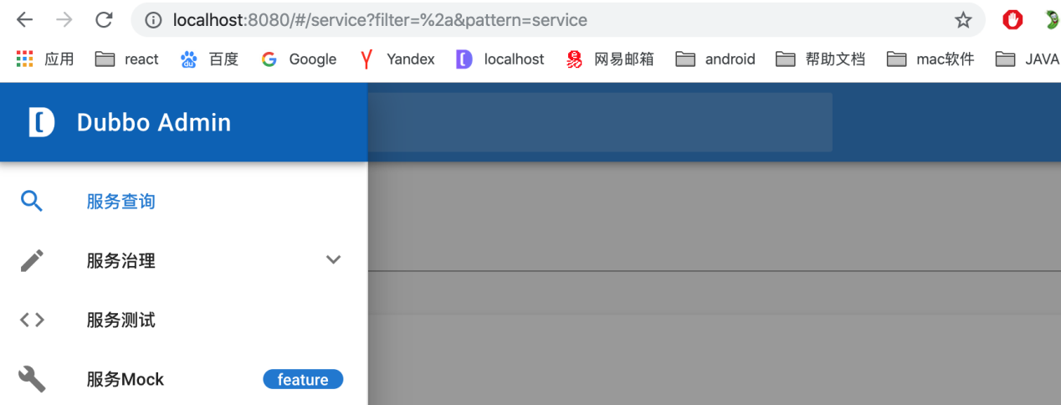

上面这个管理界面太low了

参考这个:<https://blog.csdn.net/fly910905/article/details/86212400>

参考这个：<https://www.jianshu.com/p/df1f4f88f9a4>

zookeeper分布式锁 框架

|  |
| --- |
| <dependency>  <groupId>org.apache.curator</groupId>  <artifactId>curator-recipes</artifactId>  <version>4.0.0</version>  </dependency> |